02 December, 2021

# Computer Networks Test

Time: 10:30am -1:30pm

Important instructions:

1. All programs should be commented in such a manner as to easily describe the purpose of the code used to accomplish the purpose
2. Student should show the screenshot of the output at the end of the program.

EXERCISE:

1. Given a message bit, the task is to find the hamming code of the given

message bit.

Example:

Input: S = “0101”

Output format:

Generated codeword is: 0100101

1. Consider the network shown below Fig. 1 and assume that each node initially knows the costs to each of its neighbours. Consider the link state routing algorithm and show the distance table entries at node X (Source node).

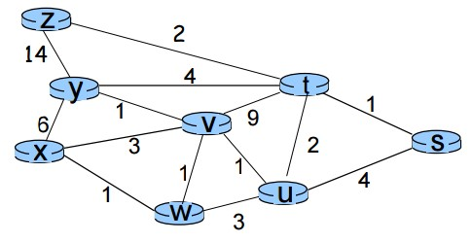

Fig. 1

1. Simulate in packet tracer environment.
2. Two routers connected with two different Pc. Configure all IP addresses assigned and check connectivity using ping command.
3. Implement DHCP server with two networks. Use network devices as reqired.